Name: Krishnaprasad Awala

Roll no:2215004

Enrollment no: MITU21BTITD006

Code :

import org.openqa.selenium.By;

//import org.openqa.selenium.chrome.ChromeDriver; import org.openqa.selenium.edge.EdgeDriver;

public class page1{

public static void main(String[] args) throws InterruptedException{ System.out.println("TESTING");

System.setProperty("webdriver.chrome.driver","C:\\salenium\\chromedriver_win32\\chromedr iver.exe");

ChromeDriver driver = new ChromeDriver(); driver.get("https://[www.facebook.com/](http://www.facebook.com/)"); Thread.sleep(1000); driver.findElement(By.id("email")).sendKeys("7470740100");

driver.findElement(By.id("pass")).sendKeys("josh1258"); driver.findElement(By.name("login")).click();

driver.get("https://[www.youtube.com/](http://www.youtube.com/)");

}

}

Facebook output-

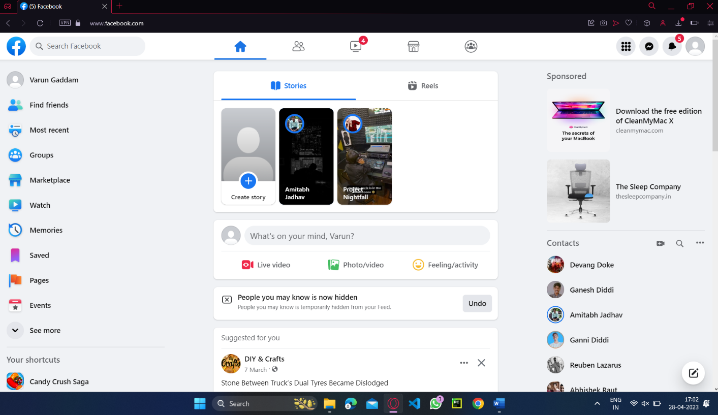

Code-

import org.openqa.selenium.By;

//import org.openqa.selenium.chrome.ChromeDriver; import org.openqa.selenium.edge.EdgeDriver;

public class page1{

public static void main(String[] args) throws InterruptedException{ System.out.println("TESTING");

System.setProperty("webdriver.chrome.driver","C:\\salenium\\chromedriver_win32\\chromedr iver.exe");

ChromeDriver driver = new ChromeDriver(); driver.get("https://[www.facebook.com/](http://www.facebook.com/)"); Thread.sleep(1000); driver.findElement(By.id("email")).sendKeys("7470740100");

driver.findElement(By.id("pass")).sendKeys("josh1258"); driver.findElement(By.name("login")).click();

driver.get("https://[www.youtube.com/](http://www.youtube.com/)");

}

}Youtube-

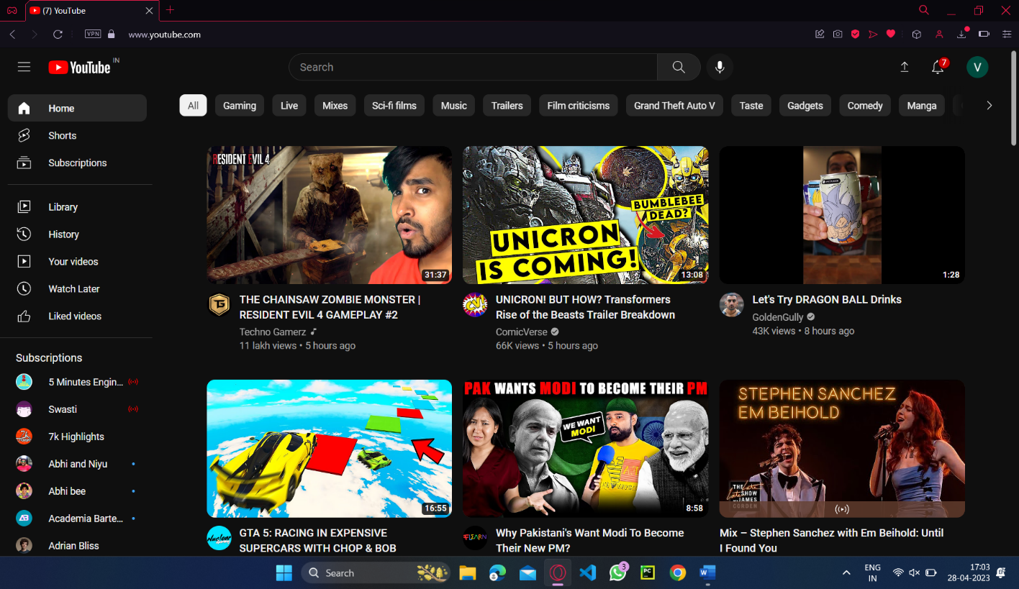

Code-

import org.openqa.selenium.By;

//import org.openqa.selenium.chrome.ChromeDriver; import org.openqa.selenium.edge.EdgeDriver;

public class page1{

public static void main(String[] args) throws InterruptedException{ System.out.println("TESTING");

System.setProperty("webdriver.chrome.driver","C:\\salenium\\chromedriver_win32\\chromedr iver.exe");

ChromeDriver driver = new ChromeDriver(); driver.get("https://[www.facebook.com/](http://www.facebook.com/)"); Thread.sleep(1000); driver.findElement(By.id("email")).sendKeys("7470740100");

driver.findElement(By.id("pass")).sendKeys("josh1258"); driver.findElement(By.name("login")).click();

driver.get("https://[www.amazon.in/](http://www.amazon.in/)");

}

}

Amazon Output :

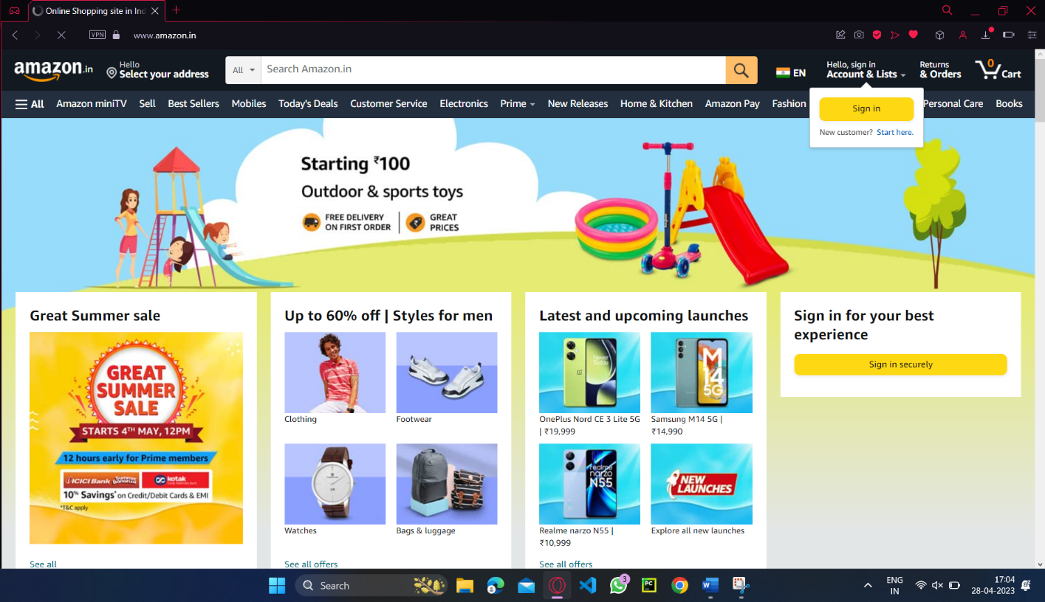

Code-

import org.openqa.selenium.By;

//import org.openqa.selenium.chrome.ChromeDriver; import org.openqa.selenium.edge.EdgeDriver;

public class page1{

public static void main(String[] args) throws InterruptedException{ System.out.println("TESTING");

System.setProperty("webdriver.chrome.driver","C:\\salenium\\chromedriver_win32\\chromedr iver.exe");

ChromeDriver driver = new ChromeDriver(); driver.get("https://[www.facebook.com/](http://www.facebook.com/)"); Thread.sleep(1000); driver.findElement(By.id("email")).sendKeys("7470740100");

driver.findElement(By.id("pass")).sendKeys("josh1258"); driver.findElement(By.name("login")).click()

driver.get("https://[www.instagram.com](http://www.instagram.com)");

}

InstagramOutput:

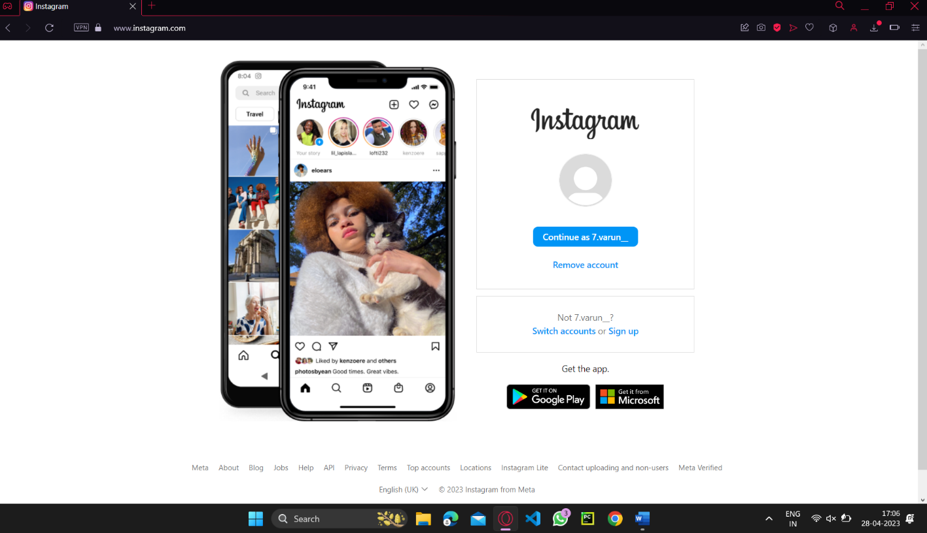

Code-

import org.openqa.selenium.By;

//import org.openqa.selenium.chrome.ChromeDriver; import org.openqa.selenium.edge.EdgeDriver;

public class page1{

public static void main(String[] args) throws InterruptedException{ System.out.println("TESTING");

System.setProperty("webdriver.chrome.driver","C:\\salenium\\chromedriver_win32\\chromedr iver.exe");

ChromeDriver driver = new ChromeDriver(); driver.get("https://[www.facebook.com/](http://www.facebook.com/)"); Thread.sleep(1000); driver.findElement(By.id("email")).sendKeys("7470740100");

driver.findElement(By.id("pass")).sendKeys("josh1258"); driver.findElement(By.name("login")).click()

driver.get("https://[www.instagram.com](http://www.instagram.com)");

}

Github Output

